**Project Title: Agriculture Data Analytics in Crop Yield Estimation using IBM Cognos**

Category: IBM Cloud Application

Skills Required:   
IBM Cloud

**Project Description:**

**Introduction**: - Crop production in India is one of the important sources of income and India is one of the top countries to produce crops. As per this project we will be analyzing some important visualization, creating a dashboard and by going through these we will get most of the insights of Crop production in India.

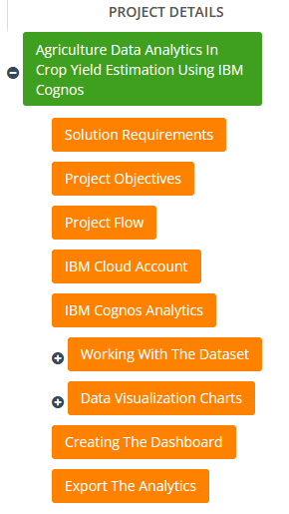

**Solution Requirements**

**Service Used**: IBM Cognos Analytics.

### cognos

**Project Objectives**

By the end of this project, you will:

* Know fundamental concepts and can work on IBM Cognos Analytics.
* Gain a broad understanding of plotting different graphs.
* Able to create meaningful dashboards

**Project Flow**

* Users create multiple analysis graphs/charts.
* Using the analyzed chart creation of Dashboard is done.
* Saving and Visualizing the final dashboard in the IBM Cognos Analytics.

To accomplish this, we have to complete all the activities and tasks listed below

* IBM Cloud Account
* Login to Cognos Analytics
* Working with the Dataset
  + Understand the Dataset
  + Loading the Dataset
* Data visualization charts
  + Seasons with average productions
  + With years usage of Area and Production
  + Top 10 States with most area
  + State with crop production
  + States with the crop production along with season (Text Table)
* Dashboard Creation
* Export the Analytics
* **IBM Cloud Account**
* Create and login to IBM Account.
* Link: <https://cloud.ibm.com/registration>
* **IBM Cognos Analytics**
* Create Cognos Analytics Account.
* Link: [IBM Cognos Account Creation](https://www.ibm.com/account/reg/in-en/signup?formid=urx-34710)

**Working with the Dataset**

**Understand the dataset**

This project is based on a understanding the crop production of India .Download the dataset from the below link. It has 2,46,092 data points (rows) and 6 features (columns) describing each crop production related details.

**Dataset Link** : https://data.gov.in/apy

Let’s understand the data we’re working with and give a brief overview of what each feature represents or should represent

1. State Name - All the Indian State names.

2. District Name -Different District names.

3. Crop Year- contains the crop years.

4. Season – Different seasons for crop production.

5. Area- Total number of areas covered.

6. Production- production of crops.

**Loading the Dataset**

Before you can build a view and analyze your data, you must first connect the data to IBM Cognos. Cognos supports connecting to a wide variety of data, stored in a variety of places.

The data might be stored on your computer in a spreadsheet or a text file, or in a big data, relational, or cube (multidimensional) database on a server in your enterprise.

In our case, we will be using a spreadsheet or text file for making our analysis. Click on the link for understanding the connection of dataset in Cognos.

**Link** : connection of dataset

Before plotting the different graphs and charts in Cognos watch a brief explanation video of the Cognos Interface.

**Link** : [Cognos Analytics Basics](https://youtu.be/TLCPgRTgp6U)

**Data Visualization Charts:**

**Creating the Dashboard**

Created views on different tabs in Cognos analytics, pull them into a dashboard for data visualization column graphs and pie charts

Using the Crop production in Indian dataset, we plan to create various graphs and charts to highlight the insights and visualizations.

### 1. Seasons with Average Productions

### As production of crops depends on different seasons, so let’s plot the graphs to visualize the average production based on different seasons.

### C:\Users\prabhakar143\Documents\ShareX\Screenshots\2022-07\2022-07-19_19-42-06.png

### Figure.1: Visuvalization graph of average production based on different seasons

### C:\Users\prabhakar143\Documents\ShareX\Screenshots\2022-07\2022-07-19_19-47-35.png

### Figure.2: Visualization pie chart of average production based on different seasons

### Table.1: Average production based on different seasons

|  |  |
| --- | --- |
| Season | Average Production |
| Autumn | 13065.67 |
| Kharif | 42743.34 |
| Rabi | 31011 |
| Summer | 11522.38 |
| **Winter** | **71826.42** |
| Whole Year | 2395012 |
|  |  |

### Summary: In winter season maximum 71826.42 and in Rabi season minimum 31011 and whole year 2395012 average crop productions observed.

### 2. With years usage of Area and Production

In our dataset we also have a year’s columns by which we will plot a line and area graphs to see the change in these both data with respect to increase in years.

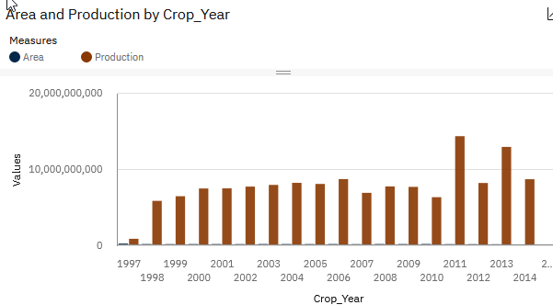

Figure.3:Area graph of Average Production data with respect to increase in years.

|  |  |  |
| --- | --- | --- |
| Crop\_Year | Values | Measures group |
| 1997 | 231715046 | Area |
| 1997 | 851232906 | Production |
| 1998 | 166988082 | Area |
| 1998 | 5825320640 | Production |
| 1999 | 158666106 | Area |
| 1999 | 6434665985 | Production |
| 2000 | 165297477 | Area |
| 2000 | 7449709127 | Production |
| 2001 | 165295604.7 | Area |
| 2001 | 7465540840 | Production |
| 2002 | 157769017.2 | Area |
| 2002 | 7696955163 | Production |
| 2003 | 172088098.5 | Area |
| 2003 | 7917973505 | Production |
| 2004 | 167878424.7 | Area |
| 2004 | 8189461695 | Production |
| 2005 | 163136376.3 | Area |
| 2005 | 8043757330 | Production |
| 2006 | 170699101.7 | Area |
| 2006 | 8681913124 | Production |
| 2007 | 152724165.3 | Area |
| 2007 | 6879442339 | Production |
| 2008 | 171232070 | Area |
| 2008 | 7717018402 | Production |
| 2009 | 165694709 | Area |
| 2009 | 7660494025 | Production |
| 2010 | 176619202 | Area |
| 2010 | 6307608525 | Production |
| 2011 | 153629160.9 | Area |
| 2011 | 14308904087 | Production |
| 2012 | 152469799 | Area |
| 2012 | 8171054746 | Production |
| 2013 | 141524909.3 | Area |
| 2013 | 12903588633 | Production |
| 2014 | 115757541.6 | Area |
| 2014 | 8664540631 | Production |
| 2015 | 4601298 | Area |
| 2015 | 6935064.7 | Production |

In 2011 minimum and in the year of 2011 maximum crop average production observed.

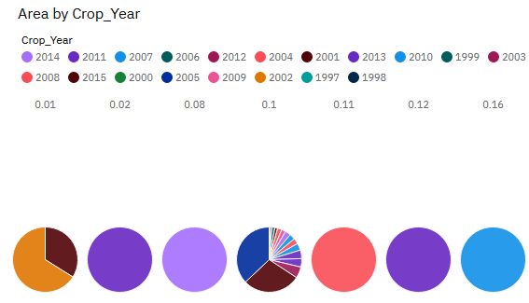

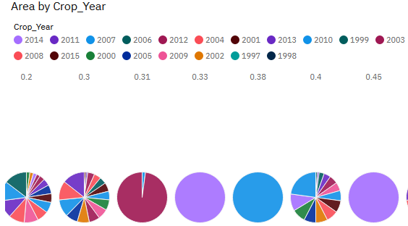

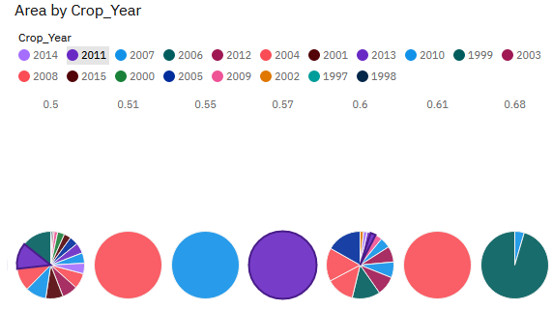

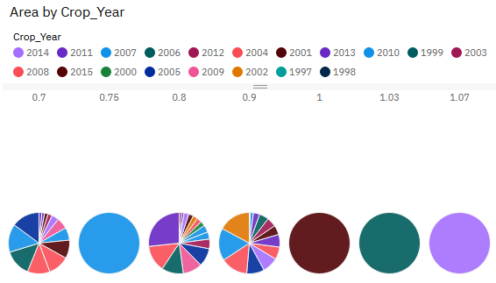

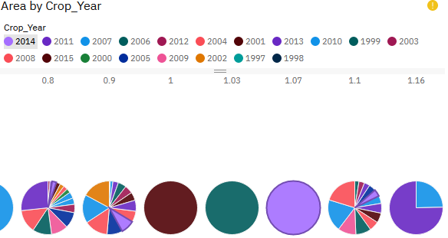

### 3. Top 10 States with Most Area

As we have an area data in our dataset, we will be plotting some graphs to visualize

the top 10 Indian states with the most area.

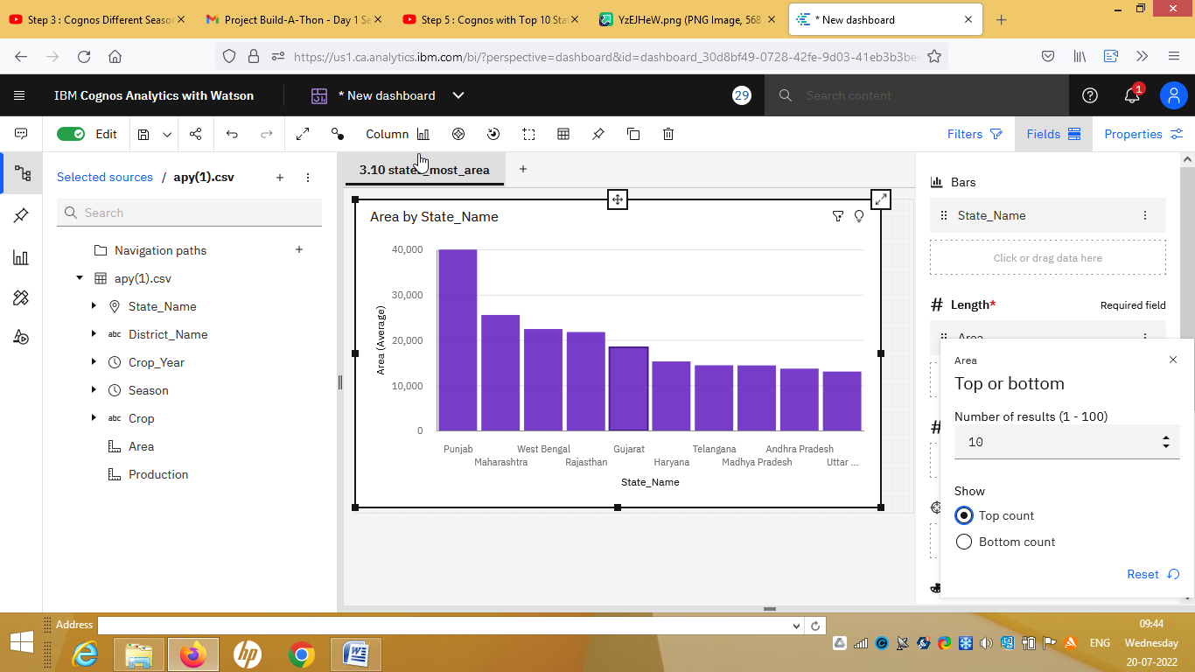

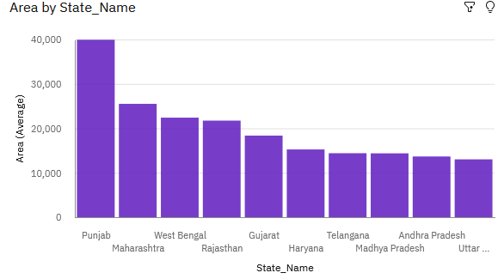

|  |  |  |
| --- | --- | --- |
| SNo. | State Name | Area(Average) Value |
| 1 | Punjab | 39938.73 |
| 2 | Maharashtra | 25515.22 |
| 3 | West Bengal | 22407.7 |
| 4 | Rajasthan | 21737.65 |
| 5 | Gujarat | 18367 |
| 6 | Haryana | 15250.61 |
| 7 | Telangana | 14402.66 |
| 8 | Madhya Pradesh | 14375.33 |
| 9 | Andhra Pradesh | 13662.84 |
| 10 | Uttar Pradesh | 13019.62 |

In Punjab most area in top 10 states and Uttar Pradesh is the least one observed.

**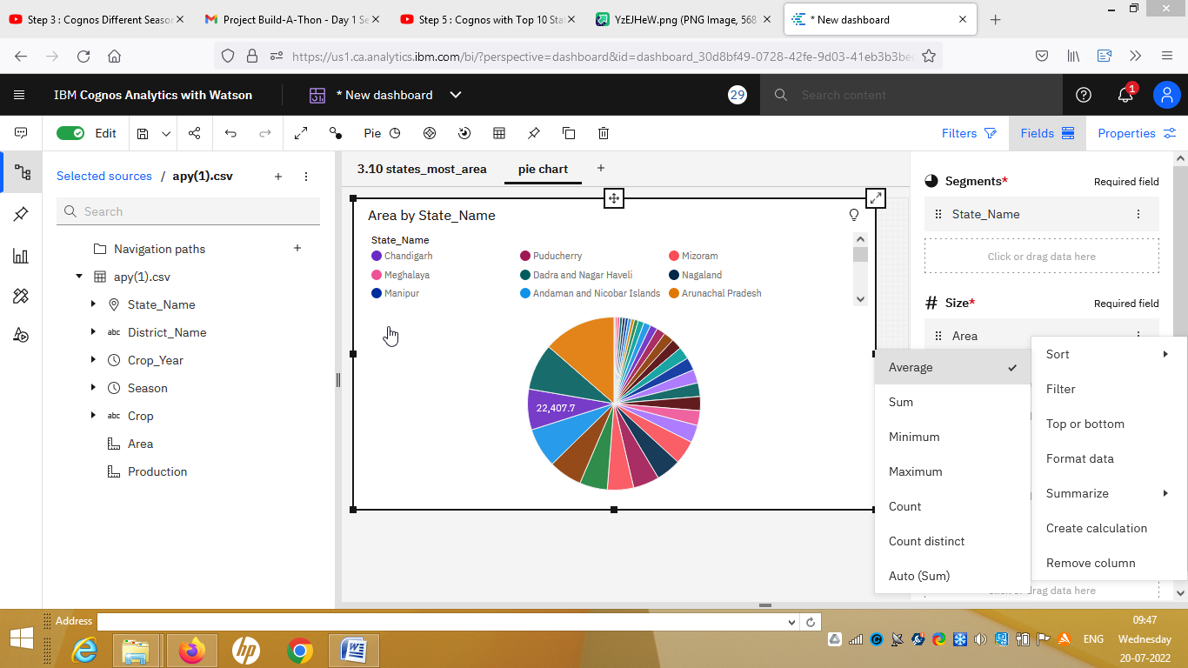**

**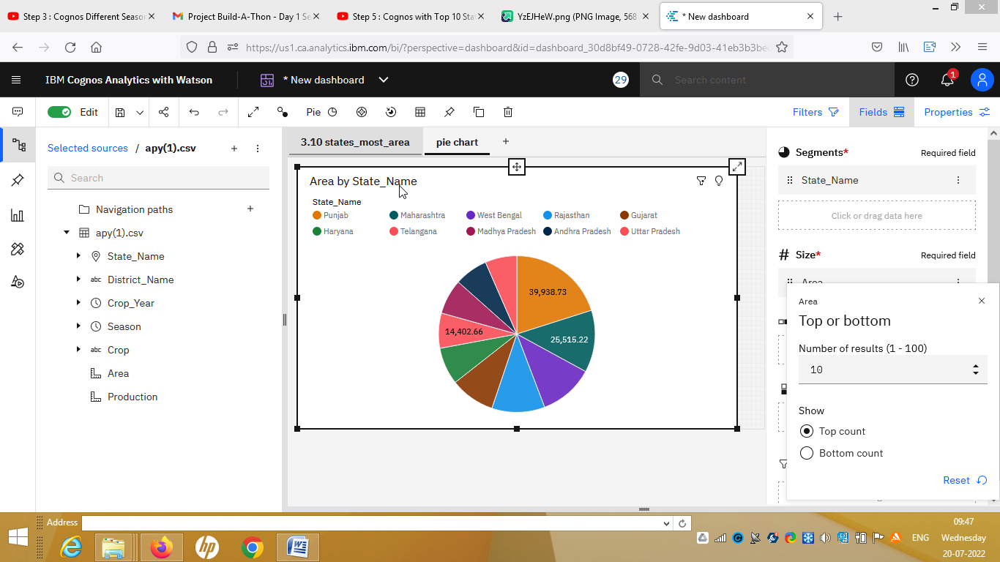**

**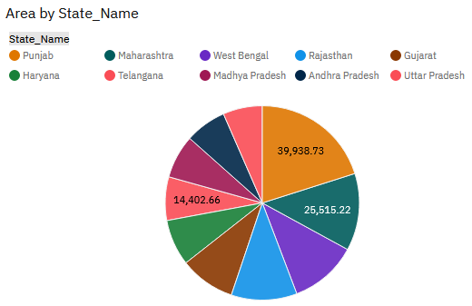**

### 4. State with Crop Production

There are so many different crops produced in Indian and most of us don’t know which crop is belongs to which state so we will be plotting and highlight the states in map according to different crops.

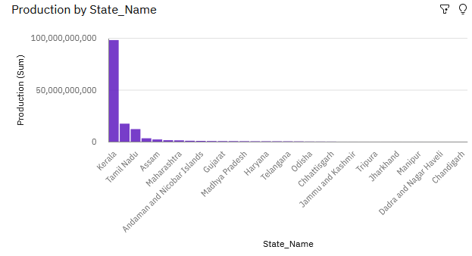

|  |  |
| --- | --- |
| State\_Name | Production |
| Kerala | 24451673 |
| Andaman and Nicobar Islands | 3573250 |
| Goa | 2443265 |
| Andhra Pradesh | 1812006 |
| Tamil Nadu | 910330.4 |
| Puducherry | 441197.8 |
| Punjab | 186568.6 |
| West Bengal | 145660.6 |
| Assam | 144422.9 |
| Maharashtra | 101123.6 |
| Uttar Pradesh | 97456.77 |
| Haryana | 83981.03 |
| Gujarat | 62676.79 |
| Telangana | 59944.18 |
| Karnataka | 40961.61 |
| Uttarakhand | 27394.27 |
| Rajasthan | 23315.12 |
| Madhya Pradesh | 19856.7 |
| Bihar | 19417.38 |
| Odisha | 11897.67 |
| Chhattisgarh | 9736.87 |
| Tripura | 8868.92 |
| Jharkhand | 8513.22 |
| Jammu and Kashmir | 8144 |
| Himachal Pradesh | 7249.66 |
| Dadra and Nagar Haveli | 7026.13 |
| Meghalaya | 4224.8 |
| Manipur | 4131.85 |
| Sikkim | 3411.39 |
| Nagaland | 3269.97 |
| Arunachal Pradesh | 2681.3 |
| Mizoram | 1741.66 |
| Chandigarh | 718.61 |

Kerala is the top average crop production with value of 24451673 and Chandigarh with least value 718.61

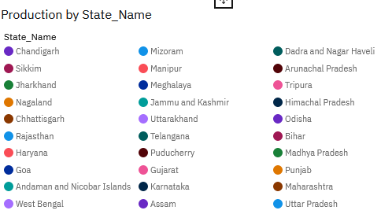

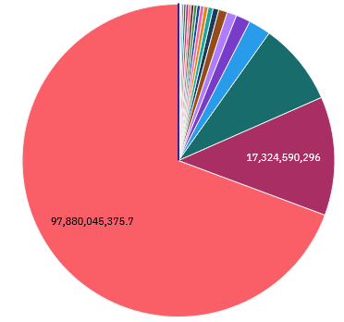

### 

### C:\Users\prabhakar143\Documents\ShareX\Screenshots\2022-07\2022-07-19_20-05-04.png

**5.States with the crop production along with season (Text Table)**

Taking forward the previous plot we will be fetching the state name and showing it in a text table whenever different crops are chosen.

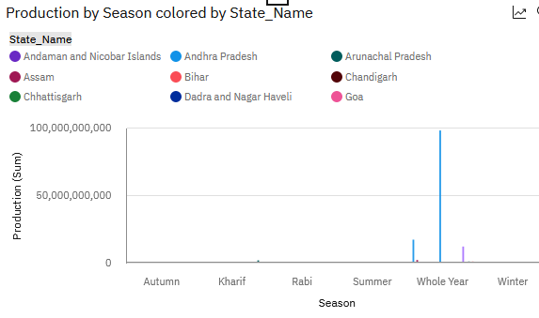

|  |  |  |
| --- | --- | --- |
| Season | Production | State\_Name |
| Autumn | 4208.16 | Andaman and Nicobar Islands |
| Autumn | 14644.48 | Assam |
| Autumn | 27500.51 | Bihar |
| Autumn | 6565.49 | Jharkhand |
| Autumn | 15576.69 | Kerala |
| Autumn | 2813.57 | Maharashtra |
| Autumn | 3757.38 | Manipur |
| Autumn | 6483.2 | Meghalaya |
| Autumn | 6570.99 | Odisha |
| Autumn | 5422.5 | Puducherry |
| Autumn | 18496.77 | West Bengal |
| Kharif | 9738.14 | Andaman and Nicobar Islands |
| Kharif | 47631.02 | Andhra Pradesh |
| Kharif | 4652.84 | Arunachal Pradesh |
| Kharif | 3748.01 | Assam |
| Kharif | 5277.15 | Bihar |
| Kharif | 228.44 | Chandigarh |
| Kharif | 20196.9 | Chhattisgarh |
| Kharif | 4107.88 | Dadra and Nagar Haveli |
| Kharif | 14767.25 | Goa |
| Kharif | 41949.89 | Gujarat |
| Kharif | 43470.8 | Haryana |
| Kharif | 7301.3 | Himachal Pradesh |
| Kharif | 11688.46 | Jammu and Kashmir |
| Kharif | 2013.76 | Jharkhand |
| Kharif | 21734.52 | Karnataka |
| Kharif | 469.54 | Kerala |
| Kharif | 18220.47 | Madhya Pradesh |
| Kharif | 74498.52 | Maharashtra |
| Kharif | 9402.06 | Manipur |
| Kharif | 4550.75 | Meghalaya |
| Kharif | 2278.75 | Mizoram |
| Kharif | 3999.98 | Nagaland |
| Kharif | 9702.42 | Odisha |
| Kharif | 10692.42 | Puducherry |
| Kharif | 134388.09 | Punjab |
| Kharif | 18996.94 | Rajasthan |
| Kharif | 4577.29 | Sikkim |
| Kharif | 28023.69 | Tamil Nadu |
| Kharif | 51775.26 | Telangana |
| Kharif | 14995.76 | Tripura |
| Kharif | 119106.04 | Uttar Pradesh |
| Kharif | 9227.02 | Uttarakhand |
| Kharif | 64378.68 | West Bengal |
| Rabi | 322.19 | Andaman and Nicobar Islands |
| Rabi | 28181.51 | Andhra Pradesh |
| Rabi | 598.04 | Arunachal Pradesh |
| Rabi | 2024.24 | Assam |
| Rabi | 15999.1 | Bihar |
| Rabi | 1483.46 | Chandigarh |
| Rabi | 2971.33 | Chhattisgarh |
| Rabi | 2115.61 | Dadra and Nagar Haveli |
| Rabi | 9536.71 | Goa |
| Rabi | 31760.22 | Gujarat |
| Rabi | 126660.89 | Haryana |
| Rabi | 8543.68 | Himachal Pradesh |
| Rabi | 6287.27 | Jammu and Kashmir |
| Rabi | 2172.53 | Jharkhand |
| Rabi | 7877.23 | Karnataka |
| Rabi | 35261.92 | Madhya Pradesh |
| Rabi | 18824.56 | Maharashtra |
| Rabi | 350.19 | Manipur |
| Rabi | 1121.18 | Meghalaya |
| Rabi | 264.34 | Mizoram |
| Rabi | 1108.33 | Nagaland |
| Rabi | 950 | Odisha |
| Rabi | 1468.23 | Puducherry |
| Rabi | 224466.22 | Punjab |
| Rabi | 52060.81 | Rajasthan |
| Rabi | 864.33 | Sikkim |
| Rabi | 5972.14 | Tamil Nadu |
| Rabi | 21591.15 | Telangana |
| Rabi | 154.52 | Tripura |
| Rabi | 54076.41 | Uttar Pradesh |
| Rabi | 8598.76 | Uttarakhand |
| Rabi | 41865.48 | West Bengal |
| Summer | 32582.59 | Assam |
| Summer | 9942.77 | Bihar |
| Summer | 498 | Chhattisgarh |
| Summer | 13847.29 | Gujarat |
| Summer | 7836.68 | Karnataka |
| Summer | 8909.75 | Kerala |
| Summer | 2928.53 | Maharashtra |
| Summer | 953.33 | Manipur |
| Summer | 8144.36 | Meghalaya |
| Summer | 5215.62 | Odisha |
| Summer | 1169.9 | Puducherry |
| Summer | 1006.08 | Uttar Pradesh |
| Summer | 5417.58 | Uttarakhand |
| Summer | 73105.78 | West Bengal |
| Whole Year | 5240672.7 | Andaman and Nicobar Islands |
| Whole Year | 9095137.9 | Andhra Pradesh |
| Whole Year | 1815.24 | Arunachal Pradesh |
| Whole Year | 433304.53 | Assam |
| Whole Year | 35393.49 | Bihar |
| Whole Year | 603.04 | Chandigarh |
| Whole Year | 691.62 | Chhattisgarh |
| Whole Year | 6002080.5 | Goa |
| Whole Year | 172416.43 | Gujarat |
| Whole Year | 105298.33 | Haryana |
| Whole Year | 3370.42 | Himachal Pradesh |
| Whole Year | 481.62 | Jammu and Kashmir |
| Whole Year | 4568.49 | Jharkhand |
| Whole Year | 125929.65 | Karnataka |
| Whole Year | 32140995 | Kerala |
| Whole Year | 11304.99 | Madhya Pradesh |
| Whole Year | 1278448.5 | Maharashtra |
| Whole Year | 1629.32 | Manipur |
| Whole Year | 4537.02 | Meghalaya |
| Whole Year | 2285.99 | Mizoram |
| Whole Year | 10026.15 | Nagaland |
| Whole Year | 5980.71 | Odisha |
| Whole Year | 2138685.6 | Puducherry |
| Whole Year | 317624.73 | Punjab |
| Whole Year | 6337.69 | Rajasthan |
| Whole Year | 7004.2 | Sikkim |
| Whole Year | 1504369.7 | Tamil Nadu |
| Whole Year | 156149.1 | Telangana |
| Whole Year | 10621.03 | Tripura |
| Whole Year | 314287.67 | Uttar Pradesh |
| Whole Year | 123421.8 | Uttarakhand |
| Whole Year | 475865.47 | West Bengal |
| Winter | 116540.48 | Assam |
| Winter | 119868.3 | Bihar |
| Winter | 15367.92 | Dadra and Nagar Haveli |
| Winter | 36329.68 | Jharkhand |
| Winter | 20641.66 | Kerala |
| Winter | 4163.8 | Manipur |
| Winter | 15235.8 | Meghalaya |
| Winter | 27016.43 | Odisha |
| Winter | 8928 | Puducherry |
| Winter | 400743.81 | West Bengal |

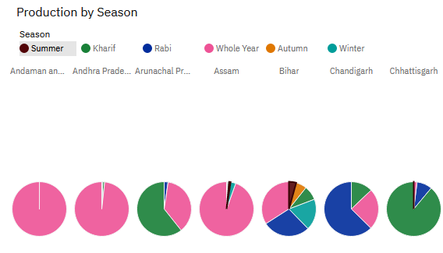

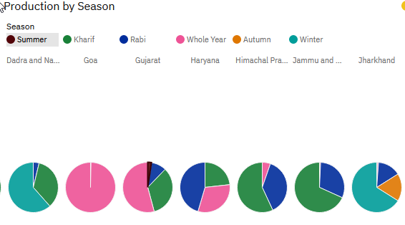

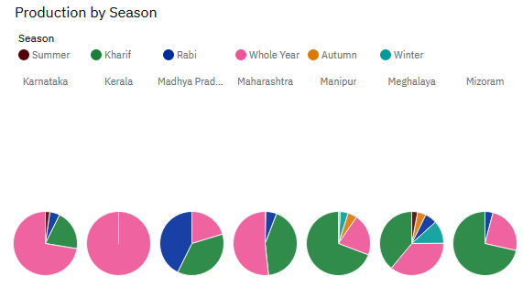

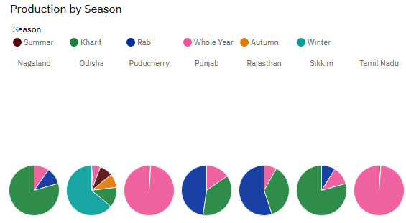

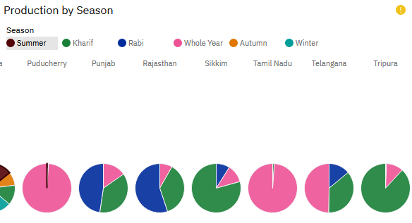

**Export the Analytics**

Finally, work shared to others through link/email as word and pdf file.